Unveiling PII in Pre-trained Models
Investigating Data Accountability in LLMs
Adnan Bakth, Mazmader
BS in CSE, North South University, adnan.mazmader@northsouth.edu
Md Abul Bashar, Nirob
BS in CSE, North South University, abul.nirob@northsouth.edu
The rapid gain in popularity for Artificial Intelligence can be credited towards Large Language Models like GPT, BERT, and many others. They have revolutionized natural language processing by enabling robust text generation capabilities. However, these advancements come with significant challenges. LLMs are often trained with huge datasets scraped off the web. This results in them being exposed to sensitive data such as personally identifiable information (PII). Our research investigates methodologies to detect the presence of PII in LLM pre-training datasets, contributing to greater data accountability. We evaluated multiple techniques, including Min-K%, Min-K%++, and proposed our novel Token Probability and Frequency Scoring (TPFS) method, across various LLMs. TPFS demonstrates robust performance by using external token frequency distributions for more reliable detection of memorized PII. After demonstrating the risks of privacy leakage via LLMs, we introduce a negative sampling-based machine unlearning approach to mitigate privacy risks. The results reveal that detecting and unlearning sensitive data is feasible, and if done on a greater scale can lay the groundwork for enhancing ethical AI practices and compliance with data protection regulations like GDPR.
CCS CONCEPTS • Security and privacy → Human and societal aspects of security and privacy → Privacy protections •Computing methodologies → Artificial intelligence → Natural language processing → Information extraction • Computing methodologies → Artificial intelligence → Natural language processing → Information extraction
Additional Keywords and Phrases: Privacy, Personally Identifiable Information (PII), Large Language Models, Token Probability, Frequency Scoring, Machine Unlearning
- Introduction
The advancement of Machine Learning (ML) and Natural Language Processing (NLP) has led to the creation of powerful generative models, such as GPT-2 and GPT-Neo. These models are trained on vast datasets collected from publicly available sources, often containing diverse information from across the internet. However, a major concern is that the publicly available datasets are not often well filtered, thus using them without any filtration for model training could lead to inclusion of Personally Identifiable Information (PII). PII can include sensitive data such as names, address, phone numbers, and other details that can be used to identify individuals. Which leads to violation of General Data Protection Regulation (GDPR) enacted by European Union in 2018. Such practice can lead to unintended privacy breaches.
Through our project we aimed to develop a novel methodology to detect PII within pre-trained Large Language Model (LLMs). Our primary goal is to identify whether specific PII has been incorporated into the training datasets of LLMs. By detecting PIIs from various models, we can enhance the integrity of the LLMs to be built in near future.
- Research literature review
Data is one of the most important factors for the success of Large Language models (LLMs). As training corpus grows in scale, it has increasing tendency to be held in-house as proprietary data instead of being publicly disclosed. However, for large-scale training corpora that consist of consequences. For example, memorized private information is vulnerable to data extraction. Till present, very few researches have been done to develop strategies for pre-training data detection.
  - Existing Research and Limitations
Membership inference attack. Membership inference attack (MIA) was first proposed by Shokri et al [1]. MIA has been extensively studied, particularly in classification models within the computer vision domain [2]. While there is growing attention to MIA in language models, most work has focused on detecting fine-tuning data [3]. MIA can serve as a powerful tool for detecting copyrighted materials [4].
Detecting Pre-training Data in LLMs. Although detecting pre-training data is an instance of MIA, it faces greater challenges compared to traditional MIA. Classical MIA [1] typically requires training a shadow model using data sampled from the training data distribution. However, for large language models, many developers are reluctant to release the full training data [5], making it impractical to train shadow models. Additionally, due to the sheer volume of training data, LLMs are usually trained for a single epoch, which makes memorization inherently difficult and detection even more challenging [2].
To our knowledge, Shi et al [6] was the first to investigate this problem, contributing a baseline method and the WikiMIA benchmark. Their method, Min-K%, despite its simplicity, serves as a powerful baseline. Zhang et al [7] enhanced Min-K% by normalizing token log-probabilities. The ReCall method [8] introduces relative conditional log-likelihoods and achieves current state-of-the-art performance
Contrastive Decoding. Contrastive decoding is primarily a method for text generation. Depending on the elements being contrasted, it serves different purposes. For example, DExperts [9] use outputs from a model exposed to toxicity to guide the target model away from undesirable outputs. Context-aware decoding [6] contrasts model outputs given a query with and without relevant context. Zhao et al [10] further enhance context-aware decoding by providing irrelevant context in addition to relevant context. In this paper, we adapt the idea of contrastive decoding to MIA, where the contrast occurs between target data prefixed with member and non-member contexts.
- methodology
The main objective of our project is to detect the presence of personally identifiable information (PII) such as full names in LLMs’ pre-training data. To achieve this, we used three different approaches. MIN-K%, MIN-K%++ and Token probability and Frequency Scoring (TPFS) have been used, out of which TPFs is our own proposed method for a better understanding of the existence of PII in the training of LLMs. This section describes all the methods explored, with all necessary equations and theoretical foundations.
  - System Design
MIN-K%: Identifying Least Probable Tokens
The MIN-K% method focuses on log probability scores of tokens given by pre-trained models. After calculating log probabilities for all tokens in a sequence, they are sorted in ascending order and the lowest K% of them is selected. The mean of those K% of the scores is the MIN-K% score. Since a more negative log-probability means higher confidence, taking the lowest k% of tokens means selecting the tokens model that recognizes the most.
Token Probabilities:
For a sequence S = {t₁, t₂, …, t_{n}}, when t_{i} represents the i-th token, the language model computes the probability P(t_{i}) for each token:
$$P\left(t_{i}\right)=softmax{\left(z\right)}_{i}= \frac{e^{zi}}{\sum_{j=1}^{V}{e^{zj}}}$$
Where z is the logits vector for token t_{i}, and V is the vocabulary size.
Sorting and Selecting the Bottom k% tokens:
Sort the token probabilities {P(t₁), P(t₂), …, P(t_{n})} in ascending order:
$$P_{sorted}=\left\{P_{1}, P_{2}, …, P_{n}\right\}, where P_{1} ≤P_{2} ≤… ≤P_{n}$$
Select the smallest k% of the token probabilities:
$$K=max⁡(1,⌊k.n / 100⌋)$$
Where K is the number of tokens in the bottom K%.
Min-K% Score:
The score is computed as the mean of the smallest k% token probabilities:
$$MIN-K\% \left(S\right)=\frac{1}{k} \sum_{i=1}^{K}{P_{i}}$$
MIN-K++: Normalized Least Probable Tokens
The MIN-K%++ method builds upon MIN-K% by normalizing token probabilities to account for variations in sequence length and probability distributions. This is achieved by transforming token probabilities into z-scores based on the mean and standard deviation of the probabilities within the sequence. The smallest k% normalized scores are then averaged to compute the MIN-K++ score, offering a more robust metric.
Normalization of Token Probabilities:
Compute the mean µ and standard deviation σ of token probabilities for the sequence:
$$µ=\frac{1}{n} \sum_{i=1}^{n}{P\left(t_{i}\right), σ=\sqrt{\frac{1}{n} \sum_{i=1}^{n}{{\left(P_{t_{i}}-µ\right)}^{2}} }}$$
Normalize each token probability:
$$P_{normalized}= \frac{P\left(t_{i}\right)- µ}{σ}$$
Sorting and selecting the Bottom K% Normalized Scores:
Similar to MIN-K%, sort the normalized probabilities and select the bottom k%:
$$P_{normalized},_{ sorted}=\{P_{1}^{normalized}, P_{2}^{normalized}, …, P_{n}^{normalized}\}$$
MIN-K++ Score:
Compute the average of the smallest K% normalized probabilities:
$$MIN-K++\left(S\right)=\frac{1}{K} \sum_{i=1}^{K}{P_{i}^{normalized}}$$
TPFS (Token probability and Frequency Scoring)
The Token Probability and Frequency Scoring (TPFS) method works by combining the token probabilities output by a pre-trained language model (e.g., GPT-2, OPT) with token frequency distributions derived from an external reference corpus. This method identifies cases where the model assigns disproportionately high probabilities to specific tokens relative to their frequency in general language usage.
Steps in TPFS
Logit Extraction and Probability Calculation:
The model processes the input tokens and outputs logits for all tokens in the vocabulary. These logits are converted into probabilities using the SoftMax function:
$$P\left(y=i | x\right)= \frac{e^{logit_{i}}}{\sum_{j}{e^{logit_{j}}}}$$
Here,
- P (y = i|x): Probability of the i-th token given the input x
- logit_{i}: Logit value for the i-th token
The probabilities for the tokens in the input sequence are stored for further computation.
Token Frequency Distribution from Reference Corpus:
For each token x_{i} in the input, its frequency is computed using a reference corpus:
$$p\left(x_{i}, D^{'}\right)= \frac{count\left(x_{i}\right)+1}{N^{'}+ |V|}$$
Where,
- count(x_{i}): Number of times the token x_{i} appears in the reference corpus
- N': Total number of tokens in the reference corpus
- |V|: Vocabulary size of the tokenizer
- +1: Laplace smoothing to avoid zero probabilities for unseen tokens
Log-Odds Calculation:
For each token x_{i}, the log-odds is computed to compare the model’s confidence with its general frequency in the reference corpus:
$$Log-Odds\left(x_{i}\right)= -P\left(x_{i};M\right).log⁡(p\left(x_{i},:D^{'}\right))$$
Here,
- P (x_{i}; M): Probability of the token x_{i} predicted by the model
- P (x_{i}; D'): Frequency of the token x_{i} in the reference corpus.
Score Aggregation:
The log-odds scores for all tokens in the name are aggregated to compute a final TPFS score for the entire sequence:
$$TPFS-Score=\frac{1}{n} \sum_{i=1}^{n}{Log-Odds(x_{i})}$$
Where n is the number of tokens in the sequence.
Comparison of Scores:
The TPFS scores for seen and unseen names are compared to analyze the model’s behavior. Names with higher TPFS scores are more likely to have been memorized by the model.
Token Probability and Frequency Scoring (TPFS) effectively accounts for names that are frequently found in general language by leveraging token frequencies derived from a reference corpus. For high-frequency names like "John Smith," the token frequency in the reference corpus will be relatively high. This reduces the impact of the log-odds calculation, as the logarithmic term becomes smaller for frequent tokens. Consequently, the final TPFS score for such names is moderated, even if the model assigns them high probabilities. This ensures that TPFS does not mistakenly flag common names as memorized, as their high probabilities are consistent with their general usage in the language. By considering both model probabilities and external frequency data, TPFS distinguishes between memorization and natural language predictions for high-frequency names, ensuring robustness in detecting genuinely memorized PII.
Unlearning:
After we were successfully able to detect the use of PII pre-training for LLMs, we decided to propose a method to resolve the issue. The fact that LLMs have seen PII during training means there is huge risk of privacy leakage. Machine Unlearning can be the key to mitigating such risks.
There are various ways this problem could be approached, but to show that our method works, we did this on a smaller scale using the GPT-2 Medium model. The dataset that we used is the Enron email dataset. Using regex we extracted the email addresses to act as our seen data and synthetic emails of the same pattern were generated to be used as unseen data.
Before unlearning, MIN-K% was applied to see a model's ability to recognize seen data so that it can be compared after unlearning.
Now, coming to the unlearning process, we applied negative sampling. That involves fine-tuning the model to overwrite its associations with sensitive data. This is done by replacing sensitive text with a generic placeholder like email@example.com. The model is set to training mode, and an optimizer (AdamW) is used to update the model parameters. During training, each piece of sensitive text is paired with the corresponding placeholder, and both are tokenized to create input and label sequences. The model minimizes the loss between its predictions and the placeholder text. Over ten epochs, the model learns to predict the placeholder instead of the original sensitive content, thereby unlearning its prior association. Average loss is monitored at each epoch to track progress, ensuring the model gradually replaces the specific patterns of sensitive data with generic, non-identifiable content. Lastly, MIN-K% was applied after unlearning and results before and after unlearning were compared.
- Result
The results for our project are visualized through Receiver Operating Characteristic (ROC) curves which show how well the model is able to distinguish between seen and unseen data. The y-axis is the True positive rate and the x-axis is the False positive rate. Each plot has three curves, one each for TPFS, MIN-K% and MIN-K%++. The closer the curve is to the top left corner, the better the performance. To get a better grasp of the results, Area Under the Curve (AUC) was also calculated. The higher the AUC value the better the method for detecting PII in pre-training data. We have run experiments on several LLMs, such as OPT 2.7B, GPT-NEO 2.7B as well as many other models.
K = 20% | K = 80% | K = 100%
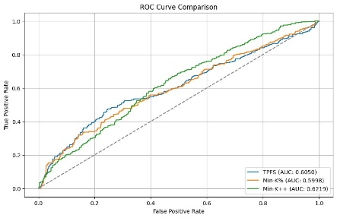 | 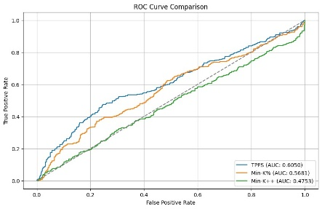 | 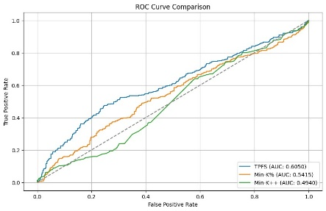
Figure 1: OPT 2.7B ROC Curve
Here, we have the results for the OPT 2.7B variant. We can see that when only K = 20% of the tokens are taken for MIN-K% and MIN-K%++ methods, the AUC is very similar. For MIN-K%++, it is the highest at 0.6219, second highest for TPFS at 0.6050 and lowest for MIN-K% at 0.5998. Even though results here are similar, we can tell TPFS works better than the other methods because MIN-K% and MIN-K%++ only consider the 20% of tokens with the highest scores. This means any token that may be part of general language could be flagged as memorized even though it is very common. For example, in the name ‘casey’, sub-word tokenization leads to the formation of the token ‘case’ which is part of general language. So, tokens like that will be part of the 20% and hence, results for MIN-K% and MIN-K%++ are biased. On the other hand, TPFS considers all the tokens in its scoring which gives us a better idea of how well the model distinguishes between seen and unseen data. TPFS solves this issue as
This is even more evident if we look at the results for K = 80% and 100%. Since higher percentages of tokens are used for scoring in MIN-K% and MIN-K%++, their AUC score decreases. For K = 100%, the AUC score had decreased to 0.5415 and 0.4940 for MIN-K% and MIN-K%++ respectively which is lower than TPFS. This shows that while selecting lower percentages of tokens for the mean score might be effective when detecting pre-training data as a whole, for smaller sequence lengths this is not as effective. Even for longer text lengths tokens such as ‘the’ and ‘a’ are selected to be in the top-K and thus results are biased. TPFS solves this issue as it scores all tokens in a sequence and aggregates their score. Also, for common tokens, their frequency score will be high and so will be the probability score, so log-odds score is adjusted so that common tokens are flagged to be not memorized.

K = 20% | K = 80 | K = 100
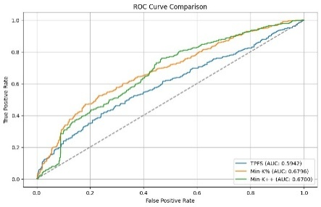 | 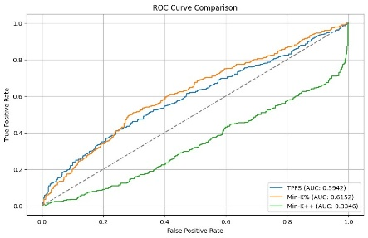 | 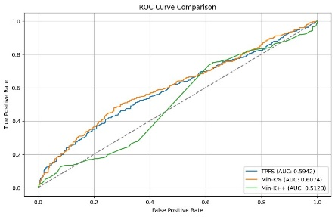
Figure 2: GPT-NEO 2.7B
results for TPFS are slightly worse than MIN-K% and MIN-K%++. TPFS had an AUC of 0.5942 whereas MIN-K% and MIN-K%++ had 0.6796 and 0.6700 respectively. But, as soon as the value for K is increased, there is a shift in the performance. The AUC for MIN-K%++ diminished quite a lot whereas for MIN-K%, it decreased to a similar level as TPFS. When K = 100%, MIN-K% and MIN-K%++ have an AUC of 0.6074 and 0.5123 respectively. So, in the case of this model, we can see the same issue with MIN-K% and MIN-K%++ where the scores are biased due to top-K tokens being part of regular language.
Table 1:Results
MODEL | TPFS | mink%(0.2) | mink%(0.8) | mink%(1) | mink++(0.2) | mink++(0.8) | mink++(1)
GPT-2XL | 0.5509 | 0.6510 | 0.5688 | 0.5714 | 0.6952 | 0.3058 | 0.5155
GPT-2 MED | 0.5132 | 0.5929 | 0.5049 | 0.5155 | 0.6643 | 0.3335 | 0.5337
GPT-NEO 1.3B | 0.5820 | 0.6475 | 0.5990 | 0.6006 | 0.6525 | 0.3290 | 0.4937
GPT-NEO 2.7B | 0.5942 | 0.6796 | 0.6152 | 0.6074 | 0.6700 | 0.3346 | 0.5123
OPT 1.3B | 0.5369 | 0.6487 | 0.5708 | 0.5753 | 0.6593 | 0.4911 | 0.3301
OPT 2.7B | 0.6050 | 0.5998 | 0.5681 | 0.5415 | 0.6219 | 0.4753 | 0.4940
Pythia 1.4B | 0.5842 | 0.6495 | 0.5996 | 0.6006 | 0.6339 | 0.3621 | 0.5277
Pythia 2.4B | 0.5608 | 0.6078 | 0.5742 | 0.5791 | 0.6139 | 0.3967 | 0.5109
The Area Under the Curve (AUC) for TPFS is generally observed to be slightly lower than that of Min-K% and Min-K%++. This is because TPFS incorporates token frequency information from an external reference corpus, which naturally reduces the sensitivity to overconfidence in predictions for high-frequency names that are common in general language. By moderating scores for such names, TPFS trades off some sensitivity for robustness, resulting in a slightly lower AUC in cases where high-frequency names are prominent.
In general Min-K%, when K = 20% does the best out of all the methods. When the value for K increases, there is always a noticeable decrease in AUC. For Min-K% across all models, K = 80% and K = 100% does not make much of a difference. But, the case with Min-K%++ is totally different. In most cases when K value is increased the performance declines, but when K is increased from 80% to 100%, there is a significant increase in performance. For example, in the case of GPT-XL, Min-K%++ had a score of 0.6952 when K = 20%, the score dropped drastically when K was increased to 80% which is much more than expected. The issue is when K is increased to 100%, the AUC increases by a lot, but it is still lower than when K is 20%. This is because Min-K%++ is based on z-score. As a result, when K is increased from 20 to 80, z-score drops as more low probability tokens are included in the final score. But when K is increased to 100, the variability in the token probabilities is reduced, resulting in a more stable z-score and a higher AUC.
For Min-K% and Min-K%++, as the value of K is increased, their scores tend to decrease and align more closely with TPFS scores. This occurs because higher values of K dilute the effect of outlier tokens with extreme probabilities, making the methods less sensitive to model overconfidence for specific tokens. This behavior mimics TPFS’s broader strategy of balancing token probabilities with external frequency distributions, thereby reducing the gap in performance between the methods at higher K.
In summary, TPFS achieves a more consistent balance by design, which explains its slightly lower AUC compared to Min-K% and Min-K++ at smaller K. However, as K increases for the other methods, they converge to similar performance levels, further validating TPFS as a robust alternative.
Moreover, as our reference corpus was not big enough, this affected TPFS as it uses the reference dataset to calculate token frequency distribution. The small size of the reference corpus underestimates token frequencies, which inflates log-odds scores for tokens, especially rare ones. This makes TPFS less effective at separating seen from unseen data compared to methods like Min-K% and Min-K++, which do not rely on external token frequency data. Therefore, having a larger reference corpus will definitely lead to better results from TPFS.
These results show the risk of privacy leakage through LLMs. As we discussed earlier, we proposed a method for mitigating such risks through negative sampling. The experiment was run on GPT-2 Medium, and MIN-K% was applied.
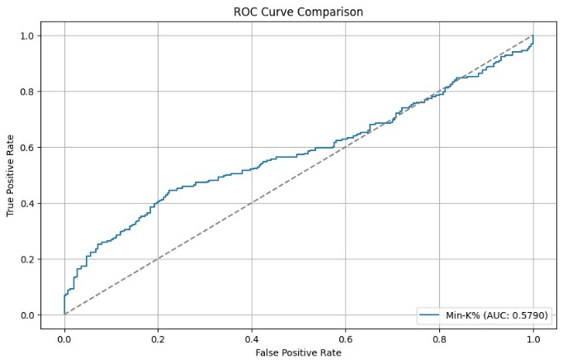 | 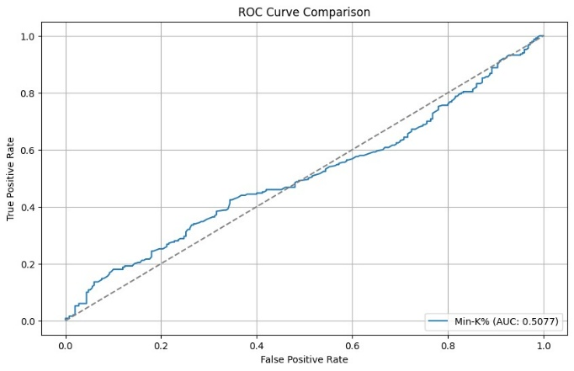
Before Unlearning | After Unlearning
Figure 3: Result of Unlearning
Before unlearning, we got an AUC score of 0.5790 which shows that model has some level of recognition towards seen data which are enron email addresses. After unlearning the score dropped to 0.5077. Even though the difference is not much, we can still say that unlearning was achieved to some extent. The results could be better if the number of epochs during unlearning was increased. But, even with only 10 epochs we were able to show that unlearning to a degree is possible. 0.5077 AUC means the model has almost no ability to distinguish between seen and unseen data. That means its association with the sensitive seen data has been minimized.
- Conclusion
This In this research, we have investigated existing methodologies for detecting the presence of Personally Identifiable Information (PII) in pre-training datasets of Large Language Models (LLMs), considering their limitations we have built a robust alternative. By addressing privacy concerns, our work contributes to enhancing data accountability and promoting ethical AI practices. We evaluated three key techniques: Min-K%, Min-K%++, and our novel Token Probability and Frequency Scoring (TPFS) method, across various LLMs, including OPT-2.7B, GPT-Neo-2.7B, and GPT-XL.
The results revealed that TPFS is a robust alternative to existing methods. Although Min-K% demonstrated the highest Area Under the Curve (AUC) when K = 20%, its performance declined significantly as K increased, converging closer to TPFS scores. TPFS’s advantage lies in its ability to evaluate all tokens while incorporating external token frequency distributions, which mitigates bias towards frequent general language tokens. This ensures a more balanced and consistent detection of PII. Despite its slightly lower AUC compared to Min-K% at smaller K values, TPFS provides superior performance, particularly as K increases or when token probabilities are diluted.
Additionally, we highlighted the risks of privacy leakage in LLMs and introduced a negative sampling-based machine unlearning approach to mitigate these risks. Initial experiments demonstrated the feasibility of this method, showcasing its potential to enhance compliance with data protection regulations such as GDPR.

References

[1] | R. Shokri, P. Liu and S. Zarifzadeh, "Low-Cost High-Power Membership Inference Attacks," Forty-first International Conference on Machine Learning, 2024.
[2] | N. Carlini, J. Hayes, M. Nasr, M. Jagielski, V. Sehwag, F. Tramer, B. Balle, D. Ippolito and E. Wallace, "Extracting training data from diffusion models," 32nd USENIX Security Symposium (USENIX Security 23), pp. 5253-5270, 2023.
[3] | M. Bertran, S. Tang, M. Kearns, J. Morgenstern, A. Roth and Z. S. Wu, "Scalable membership inference attacks via quantile regression," Advances in Neural Information Processing Systems, vol. 36, 2024.
[4] | M. Meeus, J. Shubham, M. Rei and Y.-A. d. Montjoye, "Did the neurons read your book? document-level membership inference for large language models," 33rd USENIX Security Symposium (USENIX Security 24), pp. 2369-2385, 2024.
[5] | H. Touvron, T. Lavril, G. Izacard, X. Martinet, M.-A. Lachaux, T. Lacroix, B. Roziere, N. Goyal, E. Hambro, F. Azhar, A. Rodriguez, A. Joulin, E. Grave and G. Lample, "Llama: Open and efficient foundation language models," arXiv preprint arXiv:2302.13971, 2023.
[6] | W. Shi, A. Ajith, M. Xia, Y. Huang, D. Liu, T. Blevins, D. Chen and L. Zettlemoyer, "Detecting Pretraining Data from Large Language Models," The Twelfth International Conference on Learning Representations, 2024.
[7] | J. Zhang, J. Sun, E. Yeats, Y. Ouyang, M. Kuo, J. Zhang, H. F. Yang and H. Li , "Min-k\%++: Improved baseline for detecting pre-training data from large language models," arXiv preprint arXiv:2404.02936, 2024.
[8] | R. Xie, J. Wang, R. Huang, M. Zhang, R. Ge, J. Pei, N. Z. Gong and B. Dhingra, "Recall: Membership inference via relative conditional log-likelihoods," arXiv preprint arXiv:2406.15968, 2024.
[9] | A. Liu, M. Sap, X. Lu, S. Swayamdipta, C. Bhagavatula, N. A. Smith and Y. Choi, "DExperts: Decoding-Time Controlled Text Generation with Experts and Anti-Experts," Association for Computational Linguistics, pp. 6691-6706, 2021.
[10] | Z. Zhao, E. Monti, J. Lehmann and H. Assem, "Enhancing Contextual Understanding in Large Language Models through Contrastive Decoding," Association for Computational Linguistics, pp. 4225-4237, 2024.

